Thank you for signing up with Siteground. Now there is a possibility that when you sign up you will be provided with an account created in the old control panel which is different from the site tools back end. If this is the case, I have uploaded a tutorial to help you navigate your way around it - please check further down for this tutorial titled '**How to navigate the old C Panel**'

How do you know which one is the new site tools back end?

Here is what it looks like

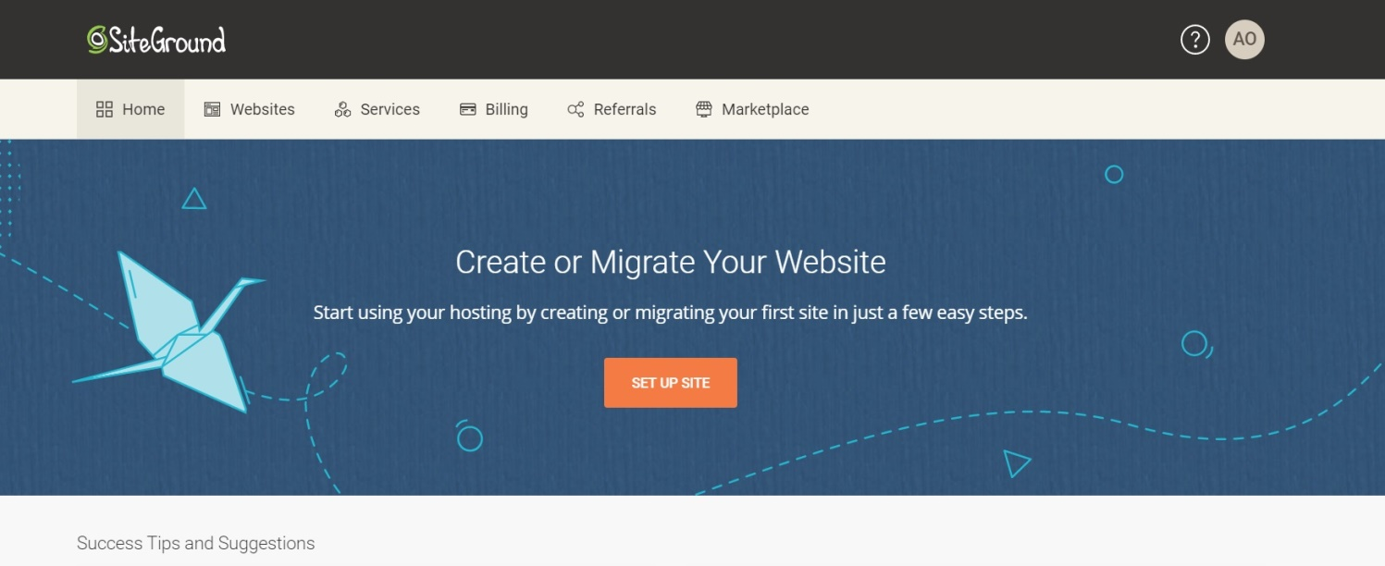new site tools

and here is how the old control panel looks like

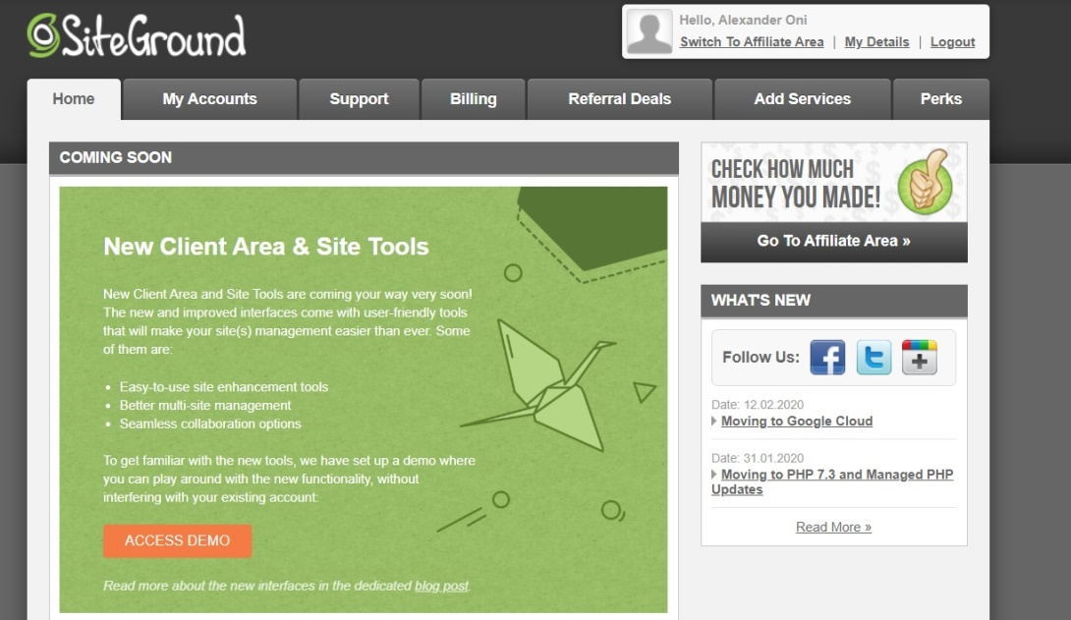old control panel

PS - If you do decide to go with Siteground hosting and pay for one of their packages, your account will automatically be transferred over to the new site tools.